Acceptance test for user story:
- Upload query FASTA file for BLASTP
Acceptance criteria:
The user is able to upload its own query FASTA file containing a single FASTA sequence after pressing the Upload Input Sequence (FASTA file) button on the Blastp GUI. To confirm the successful uploading of the query FASTA file, the name of the uploaded file is displayed on the upload button.
Step 1: Store a FASTA file locally.
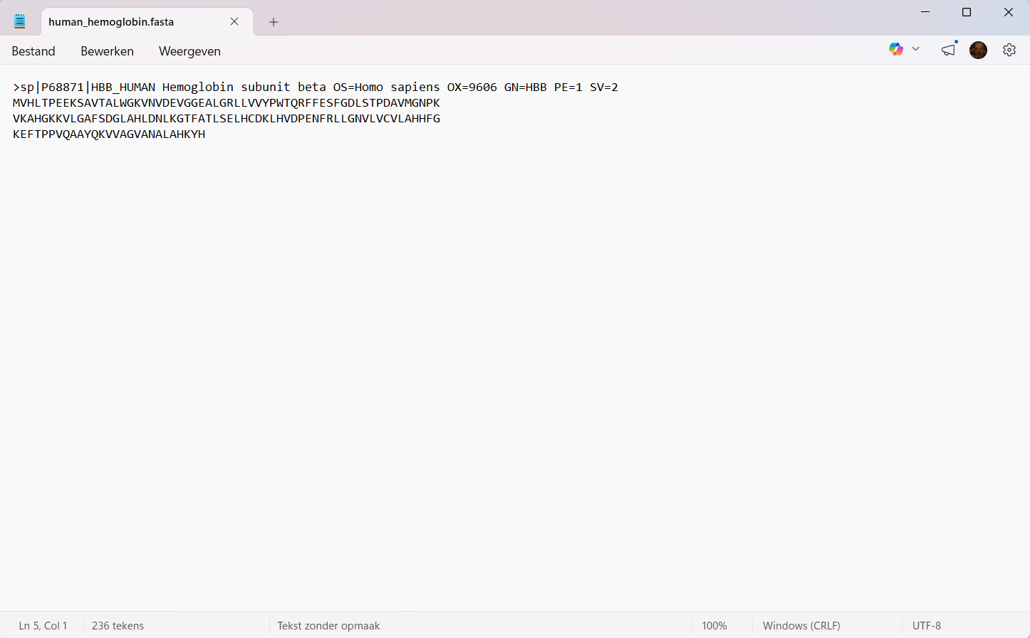
Step 2: Open the application.
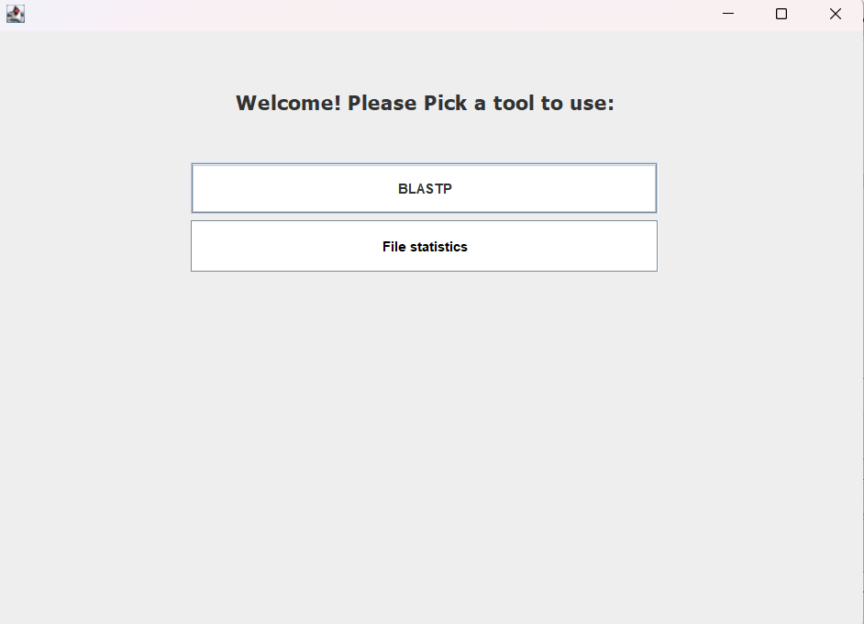
Step 3: Navigate to the BLASTP GUI by clicking the BLASTP button.
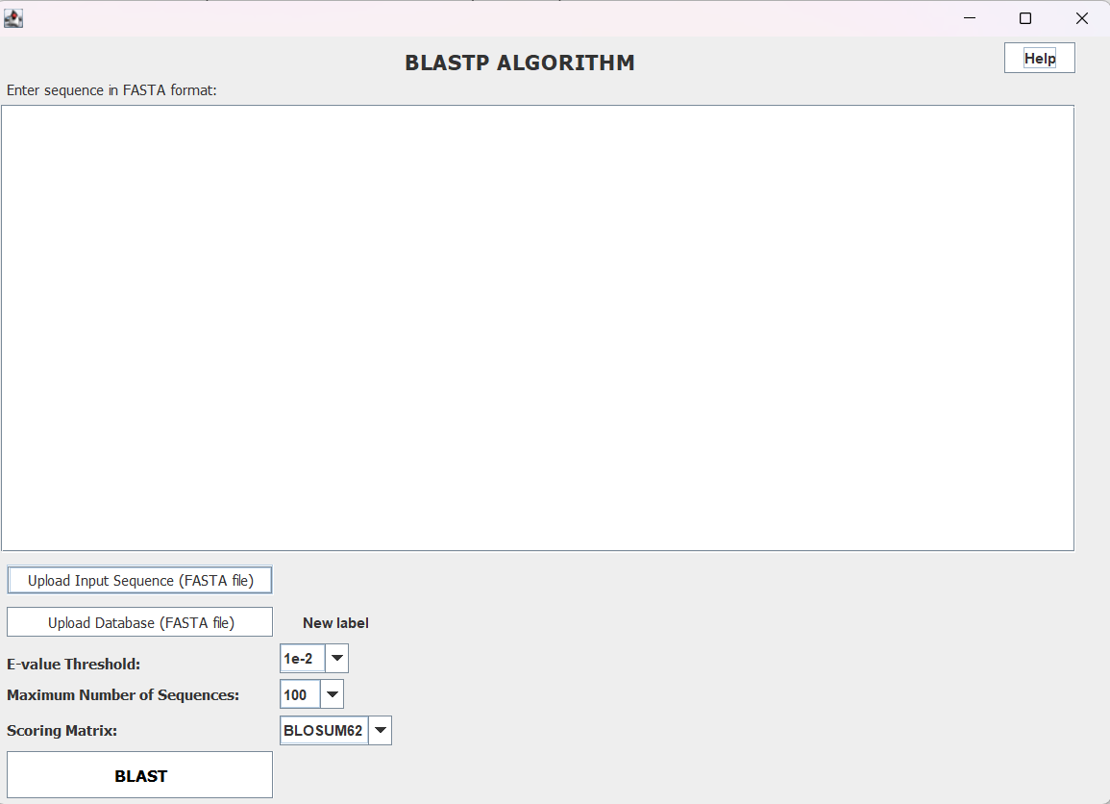
Step 4: Click the Upload Input Sequence (FASTA file) button to open your file chooser dialog.
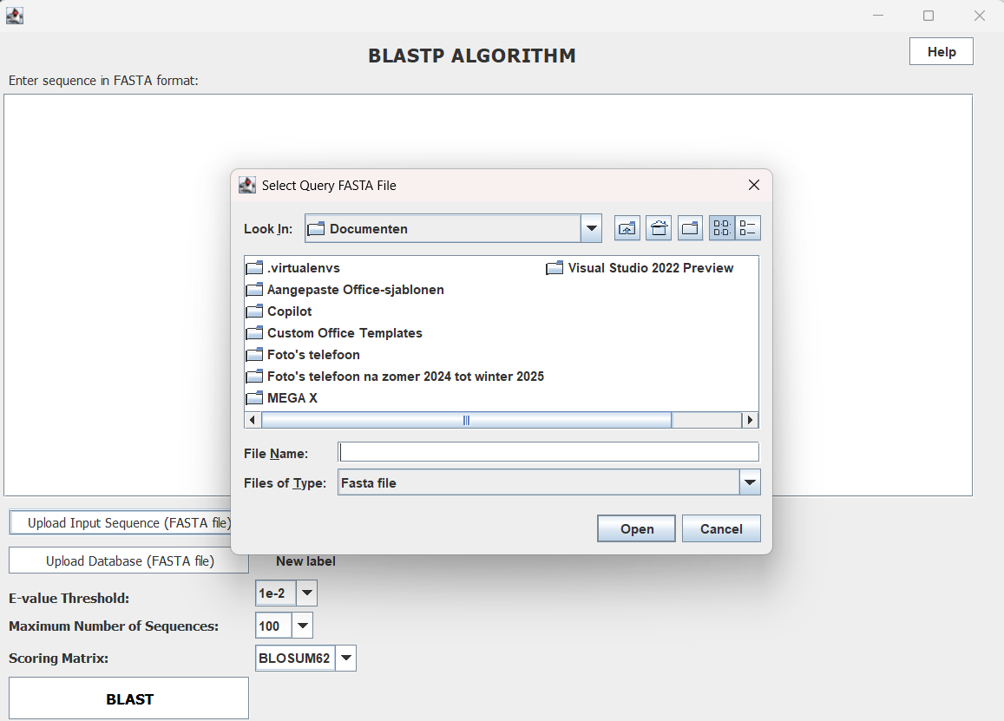
Step 5: Navigate to the FASTA file you want to upload.
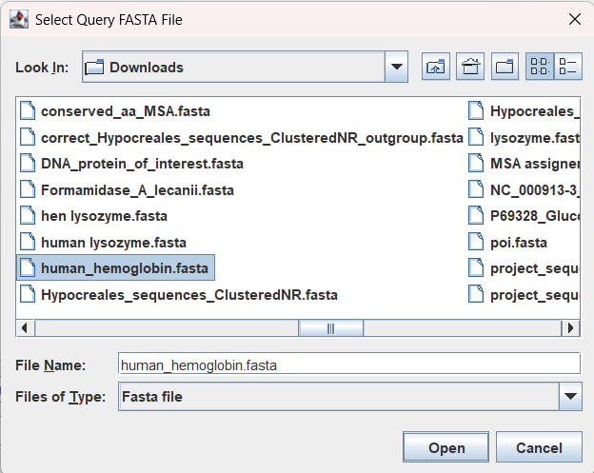
Step 6: Click the Open button to upload your FASTA file.
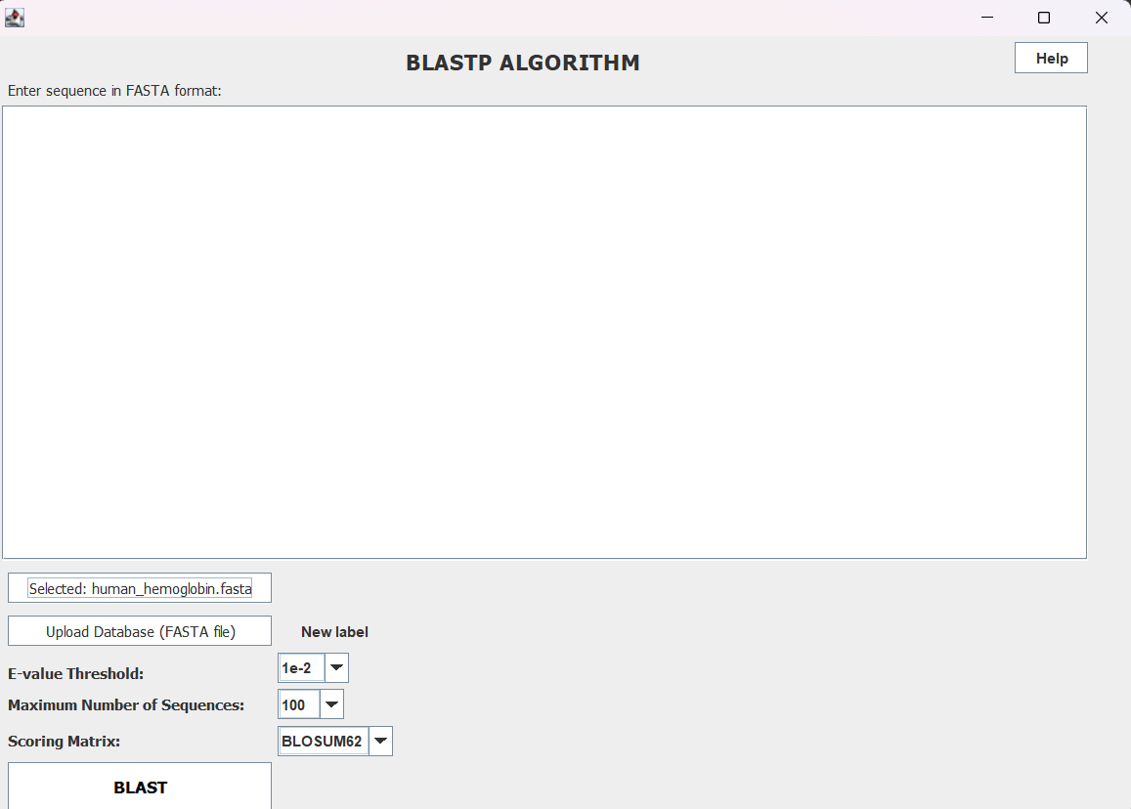
Step 7: The button now changed to: Selected: < your selected FASTA file>, showing the name of your uploaded FASTA file.

This shows the successful completion of the acceptance test.

